Diamond
The age of rough diamond, its brilliance, history and confidence turn it into the most meaningful jewelry of the world. Every diamond is unique as you are.
The Four C’s are tools that diamond professionals use them to describe the quality of a finished diamond. The 4C’s are universal and effective communication instruments for member of the diamond industry. A diamond’s value is based on the 4C’s.
IMPORTANCE OF THE 4C’S WHILE CHOOSING A DIAMOND
There are four factors while you decide a diamonds for you
- Cut
- Colour
- Clarity
- Carat Weight
CUT
The "Cut" of the "4-Cs" is the most difficult part for a consumer to judge when selecting a good diamond. It is the art, skill and, science of changing a diamond from a rough stone into a polished gem and has been known for more than two thousand years. The brilliance of diamonds depends on a perfect cut and diamond cutter’s profession. Diamond cutters must consider several factors, such as the shape and size of the crystal, when choosing a cut.
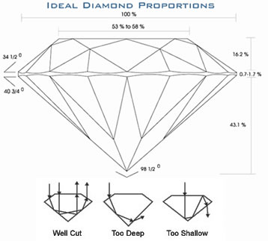
COLOR
Although many people think of gem quality diamonds as colorless, most diamonds used in jewelry are nearly colorless with tints of yellow or brown. Color grades are determined by comparing each diamond to a master set. Each letter grade represents a range of color and is a measure of how noticeable the color is.
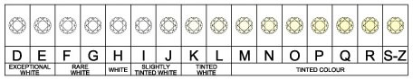
CLARITY
Given that diamonds form under tremendous heat and pressure, internal and external characteristics are common. These characteristics help gemologists separate natural diamonds from synthetics and stimulants, and identify individual stones.
There are two types of clarity characteristics: inclusions and blemishes – the difference is based on their locations. Inclusions are enclosed within a diamond while blemishes are confined to its surface.
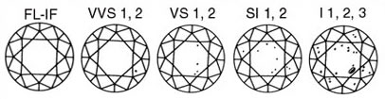

CARAT WEIGHT
One carat equals 1/5 of a gram in weight
For diamonds under a carat, each carat is divided into 100 points – similar to pennies in a dollar. 0.75ct. = 75 points, ½ ct. = 50 points
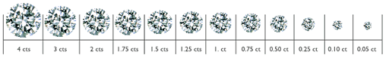
Fluorescence: Many diamonds emit a visible light when exposed to ultraviolet radiation. Although fluorescence is not a factor in determining color or clarity grades, a description of its strength and color is provided on GIA Reports for identification purposes.
Your choices define you
 | Round diamonds:  Loyal, reliable, peaceful
 | Oval diamonds:  Creative, organized, opportunist
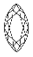 | Marquise diamonds:  Extrovert, aggressive, creative, business woman
 | Pear-shaped diamonds:  Gentle, respectful, coherent
 | Heart diamonds:  Emotional, feminine, sensitive
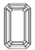 | Emerald diamonds:  Self disciplined, conservative, honest

